
.

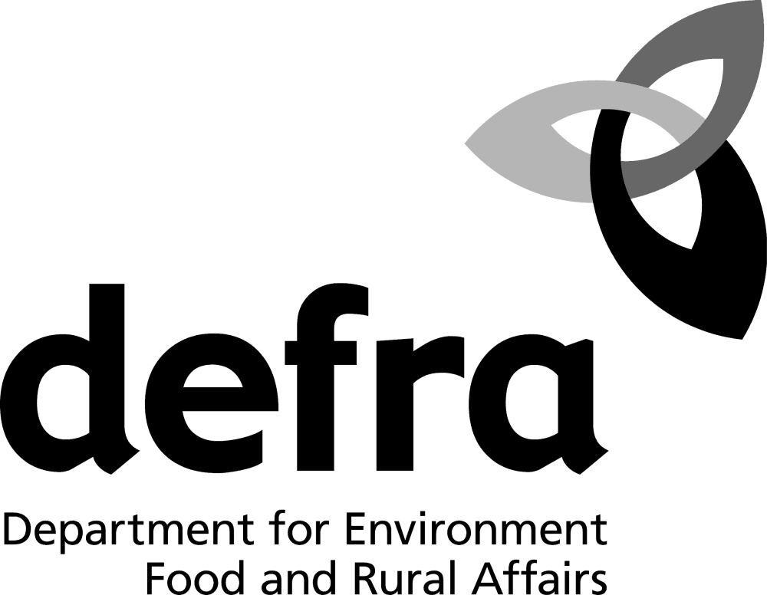

Consultation on:
(1) The Review of schedule 9 to the Wildlife and Countryside Act 1981; and
(2) The Ban on Sale of Certain Non-native Species

Response form

The closing date for the submission of responses is: 31 January 2008.

- Please complete this response form electronically (text boxes will expand), or
- Print a copy and mark all supplementary pages with your name and organisation, indicating clearly which questions your answers relate to.
- Send completed response forms to: nns.consultations@defra.gsi.gov.uk or post a hardcopy to: Matt Ashton, Protected Species and Non-native Species Team
Wildlife Species Conservation, Defra, 1/09 Temple Quay House, 2 The Square, Temple Quay, Bristol, BS1 6EB

In order to help us analyse responses, please provide details of your organisation below (Defra’s confidentiality statement: in line with Defra’s policy of openness, at the end of the consultation period copies of the responses we receive may be made publicly available through the Defra Information Resource Centre, Lower Ground Floor, Ergon House, 17 Smith Square, London SW1P 3JR. The information they contain may also be published in a summary of responses. Please see section: Publication of results.

You should also be aware that there may be circumstances in which Defra will be required to communicate information to third parties on request, in order to comply with its obligations under the Freedom of Information Act 2000 and the Environmental Information Regulations.
- Further information: http://www.defra.gov.uk/corporate/opengov/index.htm.

Name: City of London Law Society, Planning and Environmental Committee

Organisation: CITY OF LONDON LAW SOCIETY

Please indicate which category of organisation you represent: Select ONE option from the list below by clicking on the relevant box
Government (incl. Agency)
Transport
Conservation/NGO
Developers
Trade organisation
Academic/Research
Private individual
Professional body/individual
Land/Water management
Other

Other category (Please specify):

Address details:  4 College Hill  London | Phone number: 0207 329 2173
Address details:  4 College Hill  London | Mobile number: -
Address details:  4 College Hill  London | Email: mail@citysolicitors.org.uk
Post code: EC4R 2RB | Website: www.citysolicitors.org.uk

Publication of Results

Are you responding:  a) As an individual (Please go to c) | Yes: No:
b) On behalf of a group/organisation (go to e) | Yes: No:

Individuals
c) Do you agree to your response being made available to the public in the Defra library and on the Defra website? (Responses from consultees in Wales will also be copied to the Welsh Assembly Government.)  If Yes, please go to d. If your answer is No we will treat your response as confidential. | Yes: No:
d) Where confidentiality is not requested, we will make your response available to the public on the following basis (please tick one of the following boxes)

Yes, make my response, name and address all available.

Yes, make my response available, but not my name or address.

Yes, make my response and name available, but not my address.

Response on behalf of groups or organisations

e) The name and address of your organisation will be made available to the public in the Defra library and on the Defra website. (Responses from consultees in Wales will also be copied to the Welsh Assembly Government.) Are you also content for your response to be made available? If your answer is No we will treat your response as confidential. | Yes: No:

Sharing responsibilities/future engagement – all respondents
We may share your response internally with other policy teams in GB Administrations who may be addressing the issues you discuss. They may wish to contact you again in the future, but we require your permission to do so. Are you content to be contacted again in relation to this consultation response? | Yes: No:

The Review of schedule 9 to the Wildlife and Countryside Act 1981 and the ban on sale of certain non-native species – Consultation Response Form - 2

The questions in the consultation documents are reproduced under each part heading below. Please tick where appropriate and include any comments in the spaces provided. (Expand comments boxes as necessary.)

Consultation document part 2.1: Animal species proposed for addition to schedule 9, part I
1) Do you agree with the proposal to add these animal species proposed for addition to schedule 9, part I to the Wildlife and Countryside Act 1981? | Yes: No:
Comments:
2) Are there any species in the list above that you think should not be added? Please give your reasons in detail. | Yes: No:
Comments:
3) Are there any species missing from the list above that you think should be added? Please refer to the JNCC checklist and guidance at Annex B for assistance in proposing additional species. | Yes: No:
Comments:
4) Do you have any comments on the checklist and guidance provided? | Yes: No:
Comments:
5) Do you have any other comments about the addition of animal species to schedule 9? | Yes: No:
Comments:

Consultation document part 2.2: Animal species proposed for removal from schedule 9, part 1
6) Do you agree with the proposal to remove these animal species from schedule 9 to the Wildlife and Countryside Act 1981? If not, please explain in detail. | Yes: No:
Comments:
7) Are there any other species that you think should be removed from schedule 9 to the Wildlife and Countryside Act 1981? Please refer to the JNCC checklist and guidance at Annex B for assistance in proposing species for removal from schedule 9 and use the form supplied. | Yes: No:
Comments:
8) Do you have any other comments about the removal of animal species from schedule 9? |  | Yes: No:
Comments:

The Review of schedule 9 to the Wildlife and Countryside Act 1981 and the ban on sale of certain non-native species – Consultation Response Form – 3

Consultation document part 2.3: Plant species proposed for addition to schedule 9, part II
9) Do you agree with the proposal to add these plant species to schedule 9, part II to the Wildlife and Countryside Act 1981? |  | Yes: No:
Comments: We agree with the addition of certain plant species to schedule 9, in particular, species which (i) are highly invasive (ii) are difficult to remove and/or (iii) restrict or affect land use development.

However, while there is no requirement for an owner or developer to prevent such species growing on his land, the addition of such species to schedule 9 will place a burden on landowners and developers to remove the species from their land prior to development, at a cost, in accordance with the law (i.e. by ensuring that they do not plant or otherwise cause them to grow in the wild). The addition of species to schedule 9 should, therefore, be accompanied by the requisite incentives (e.g. tax relief on the cost of removal), as discussed below at 14, to ensure that the addition of species does not overly deter the purchase and development of sites affected by these species. Essentially, care must be taken to ensure that any additions to schedule 9 do not potentially restrict or deter brownfield development.

We cannot comment on the technical/scientific aspects of each of the proposed new species, but do have particular experience in this area with the difficulties caused to land owners and developers, with plants such as Japanese Knotweed (already included within schedule 9). The context of this experience includes acting for buyers and sellers on the sale of sites affected by this highly invasive and destructive species.

The discovery of Knotweed on a site can have substantial practical and economic implications. The cost of off site removal of Knotweed is particularly expensive and on the purchase of a site, off-site removal will often be perceived as the only option for a developer (rather than lengthy on-site biological treatment) due to contractual time constraints relating to a development. A combination of the invasive nature of this species and the fact that its unauthorised disposal is a criminal offence, means that sites contaminated with Knotweed are less attractive to developers, and as the results of a recent government consultation shows, the existence of Knotweed is generally thought to be a barrier to development.

The addition of new species to schedule 9 will mean site owners/developers, prior to redeveloping a site, will, where relevant, have to factor in costs to ensure that these species are disposed of legally (even if the species are not damaging to buildings in the same way as Knotweed). This may lessen the value of sites on which these species are present.
10) Are there any species on the list above that you think should not be added? Please give your reasons in detail. | Yes: No:
Comments:
11) Are there any species missing from the list above that you think should be added? Please refer to the JNCC checklist and guidance at Annex B for assistance in proposing additional species. |  | Yes: No:
Comments:
12) Do you have any comments on the checklist and guidance provided? | Yes: No:
Comments:
13) In scheduling Sea Buckthorn, it is proposed that the prohibition in section 14 should apply only in defined areas where it is non-native and causing ecological damage to native biodiversity. Do you agree with this approach? How should these areas be defined? |  | Yes: No:
Comments:
14) Do you have any other comments about the addition of plant species to schedule 9? | Yes: No:
Comments: Our comments relate to the commercial impact on landowners and developers and to the impact on development in general, of adding species (which are highly invasive and affect land use development) to schedule 9.

The addition of species to schedule 9 which are likely to be present on development sites (and may therefore require off-site removal/destruction) should benefit from land remediation tax relief in the same, or a similar way, that is currently proposed by the government for sites affected by Japanese Knotweed.

Without being qualified to comment specifically on the characteristics of the proposed new schedule 9 species, as a general principle, remediation tax relief should be available for those plant species which are commonly prevalent on brownfield sites and on derelict land. As a compromise, further research may be required to assess which (if not all) of the additions to schedule 9, should benefit from remediation tax relief.

It is likely that, with the addition of a large number of new species to schedule 9, further "barriers to development" will arise in respect of sites affected by such species, in much the same way as has been shown to occur with Knotweed. Such sites are likely to be less attractive to developers, in some cases requiring great expenditure to remove the schedule 9 species they contain. Accordingly, impacted sites would be less likely to be developed and this will often mean that the offending species will remain and potentially spread. Tax incentives would be beneficial in persuading developers to purchase and remediate these sites.

It is our understanding that currently the tax relief proposed for Knotweed will only be available where the offending Knotweed is NOT subsequently landfilled. While we agree with the general policy of actively discouraging landfilling, there needs to be viable alternatives for individuals/companies faced with the task of removing Knotweed (or indeed any other proposed schedule 9 species) prior to commencing development (or selling a property). While on-site biological remediation is effective, it is time consuming and, therefore, in many cases, cannot viably be pursued by a developer. Further research into viable alternatives may be appropriate.

Consultation document part 2.4: Costs and benefits of adding species to, or removing species from, schedule 9
15) What costs or benefits might there be to your sector or business from prohibiting introduction of these species to the wild? |  | Yes: No:
Comments:
16) If adding certain species to schedule 9 will have an impact on your business, what alternative action might you take or what alternative species might you use? |  | Yes: No:
Comments:
17) Would the addition to, or removal from, schedule 9 of any of the proposed species have beneficial or detrimental environmental impacts other than those identified in the tables in the consultation document? |  | Yes: No:
Comments:
18) Would the addition to, or removal from, schedule 9 of any of the proposed species have beneficial or detrimental social impacts? |  | Yes: No:
Comments:
19) Are there any relevant business areas not yet identified in this consultation paper or the Impact Assessment? | Yes: No:
Comments:
20) Do you have any other comments about the costs and benefits? | Yes: No:
Comments:

The Review of schedule 9 to the Wildlife and Countryside Act 1981 and the ban on sale of certain non-native species – Consultation Response Form – 4

Consultation document part 3.1: Japanese knotweed
21) Do you agree that in respect of Japanese knotweed, which is currently listed on part II of schedule 9, Fallopia japonica, should be included under the scientific names as a synonym for Polygonum cuspidatum? | Yes: No:
Comments:

Consultation document part 3.2: Hybrids of schedule 9, part I species (animals)
22) Do you agree to the introduction of a provision that makes it clear that all hybrids of those animals listed on part I of schedule 9 are caught within the scope of section 14(1)? | Yes: No:
Comments:
23) Do you have any other comments about the issue of including animal hybrids in schedule 9? | Yes: No:
Comments:

Consultation document part 3.3: Hybrids of schedule 9, part II species (plants)
24) Do you agree to the introduction of a provision that makes it clear that all hybrids of those plants listed on part II of schedule 9 are caught within the scope of section 14(2)? | Yes: No:
Comments:
25) Do you have any other comments about the issue of including plant hybrids in schedule 9? | Yes: No:
Comments: Again, our comments relate only to those plant species which are highly invasive and affect land use development (e.g. in a way that may be a "barrier to development", like Japanese Knotweed).

We agree that plant hybrids should also be included, on the basis that they will have similar invasive qualities as the plant from which they originate. However, such hybrids should also attract remediation tax relief, as explained above under 14.

The Review of schedule 9 to the Wildlife and Countryside Act 1981 and the ban on sale of certain non-native species – Consultation Response Form - 5

Consultation document part 4.2: Non-native animal species proposed for listing on an Order to ban their sale
26) Do you agree with the proposal to ban the sale of these animal species under section 14ZA of the Wildlife and Countryside Act 1981? |  | Yes: No:
Comments:
27) Are there any species on the list above that you think should not be included? Please refer to the ‘criteria for listing’ and give your reasons in detail. |  | Yes: No:
Comments:
28) Are there any species missing from the list above that you think should be included? Please give your reasons in detail. |  | Yes: No:
Comments:
29) Do you have any other comments about the proposed ban on sale of certain non-native species? | Yes: No:
Comments:

Consultation document part 4.3: Non-native plant species proposed for listing on an Order to ban their sale
30) Do you agree with the proposal to ban the sale of these plant species under section 14ZA of the Wildlife and Countryside Act 1981? |  | Yes: No:
Comments:
31) Are there any species on the list above that you think should not be included? Please refer to the ‘criteria for listing’ and give your reasons in detail. |  | Yes: No:
Comments:
32) Are there any species missing from the list above that you think should be included? Please give your reasons in detail. | Yes: No:
Comments:
33) Do you have any other comments about the proposed ban on sale of certain non-native plant species? |  | Yes: No:
Comments:

Consultation document part 4.4: Costs and benefits of a ban on the sale of the proposed species
34) What costs or benefits might there be to your sector or business from banning the sale of these species? How much of an impact might there be in terms of cost to your business and those you employ? |  | Yes: No:
Comments:
35) If banning the sale of certain species will have an impact on your business, what alternative action might you take or what alternative species might you use? |  | Yes: No:
Comments:
36) If alternative species are available, what would be the cost to your business in making the adjustment? | Yes: No:
Comments:
37) Would a ban on sale of any of the proposed species have beneficial or detrimental environmental impacts other than those identified in the tables above? |  | Yes: No:
Comments:
38) Would a ban on sale of any of the proposed species have beneficial or detrimental social impacts other than those identified in the tables above? | Yes: No:
Comments:
39) How might a ban on sale of one or more of the proposed species impact on keepers and collectors? | Yes: No:
Comments:
40) Do you have any other comments about the costs and benefits of a ban on sale of certain non-native species? | Yes: No:
Comments:

Thank you for completing this response form.

